Task-1: Define computer, Classification of computer system, Draw the block diagram of the CPU along with the configuration of each peripheral, Programming languages classification, identify the peripherals of a computer and components in a CPU and its functions.

Definition: A computer is a fast electronic device that processes the input data according to instructions given by programmer/user and provides the desired information as output.

Computers Have Two Main Parts

- Computer Hardware
- Computer Software

- Hardware

- The hardware is the part of the computer you can touch and see.
- The computer and all equipment attached to it are called hardware.
- Example: Monitor, Keyboard, Mouse
- Software
- Software is a part of the computer you cannot touch.
- The instructions that tell it what to do are called software.
- Software consists of computer programs and procedures that perform some tasks on your computer.
- Computer software is divided into three basic types

- System software
- Application software
- Programming software

- System software :
Operating System is the base program on a computer is considered system software. It tells the computer how to work or operate. The operating system also allows you to load other programs that do specialized tasks on to your computer. (ex. Windows XP and Vista

- Application software:
Application software allows you to accomplish one or more specific (non-computer related) tasks. Such as computer games for entertainment or Microsoft Word for typing

- Programming software

Programming software provides tools to assist a computer programmer in writing programs and software.

- Block Diagram of Computer

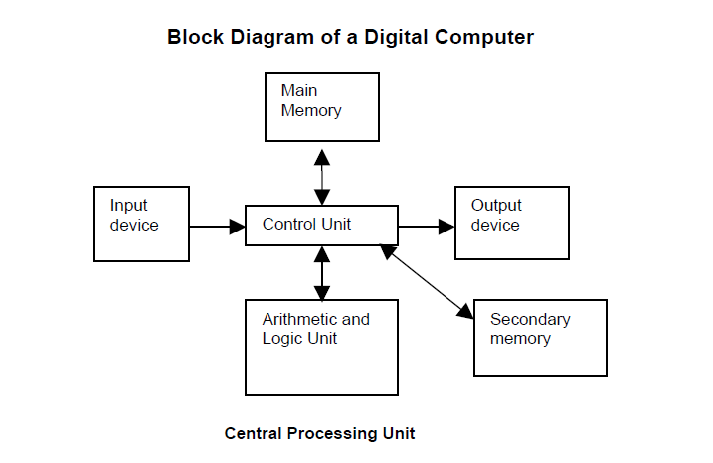
- Central Processing Unit (CPU)

- It performs all the processing of input data. In microcomputers, the CPU is built on a single chip or integrated Circuit (IC) and is called as a Microprocessor.

- CPU consists of following parts:
1. Arithmetic Logic Unit (ALU)
2. Control Unit (CU)
3. Memory Unit (MU)
4. Registers
5. Buses
6. Clock

- Memory Unit

It is used to store the data, instructions and information before, during and after the processing by ALU. It is also known as Main/Primary/Internal Memory.
It is divided into 3 types:
1. Read Only Memory (ROM)/Non-Volatile Memory
2. Random Access Memory (RAM)/ Volatile Memory
3. Complementary Metal Oxide Semiconductor Memory (CMOS)
- Read Only Memory (ROM)/Non-Volatile Memory

ROM is permanent and is not erased when system is switched off. ROM is also called Nonvolatile Memory. Memory capacity varies from 64 KB to 256 KB (1 KB = 1024 bytes).
- Types of ROM
1. Mask ROM
2. PROM (Programmable Read Only Memory)
3. EPROM (Erasable Programmable Read Only Memory)
4. EEPROM (Electrically Erasable Programmable Read Only Memory)
5. EAPROM (Electrically Alterable Programmable Read Only Memory)

- Random Access Memory (RAM)/ Volatile Memory
RAM is temporary and is erased when the computer is switched off. RAM is also called volatile Memory. Memory capacity varies from 640 KB to several megabytes (1 Megabyte = 1024 KB).
- Types of RAM
1. Dynamic RAM (DRAM)
2. Static RAM (SRAM)

Differences between Dynamic RAM & Static RAM
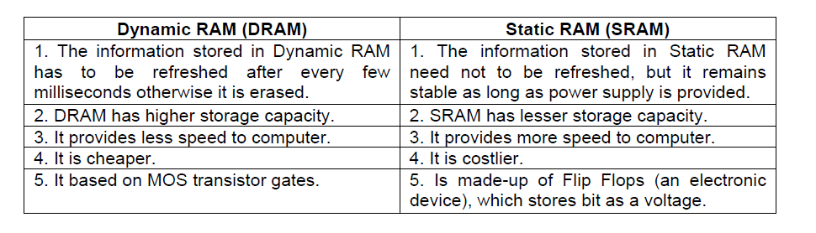

- Complementary Metal Oxide Semiconductor Memory (CMOS)
CMOS is used to store the system configuration, time, date and other important data.
- Input Devices: devices through which computer receives the information
    - Keyboard
    - Mouse
    - Scanner
- Output Devices: The output device is used to display or print result from a computer
    - Monitor
    - Printers
    - Plotter
- PROGRAMMING LANGUAGES CLASSIFICATION

1. Machine Languages / First Generation Languages

2. Assembly Languages / Second Generation Languages

3. High Level Languages

1. Machine Languages / First Generation Languages

Each processor or CPU has its own set of instructions. These instructions are binary instructions and written in a sequence of ‘0’s and ‘1’s.

Any program written by using the binary instructions are known as machine language.

Machine language for every processor is different. Writing a program in machine language is very burden and difficult.

Advantages: The advantage of the machine language code is that a processor can execute it without any transaction.

Assembly Language / Second Generation Languages

- The processor cannot understand the code written in assembly language. So, it would not be able to execute assembly language instructions.
- The processor understands the machine language. So, assembly language programs have to be converted into machine language. This is done by the assembler.
- Assembler: The assembler is a program, which converts an assembly language program into machine code (object code), which can be executed by the processor.
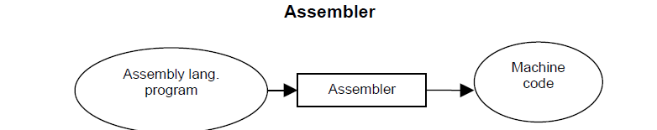
- Advantages: The advantage of the assembly language over machine language is that it is more convenient for the programmer to write programs in assembly language.
- High Level Languages (HLL)
- High-level languages are machine independent. So, it is not necessary to know the architecture details of a processor to write the programs in these languages.
Ex: COBOL, BASIC, PASCAL, ADA, C etc.
- Advantages: Writing programs in High Level Languages is more easy because they provide the construct and set of statements which are easy to use.
- Writing a program for problem in higher-level language is easier than machine and assembly language. So, program development time in high-level language is low.
Translation of High-level language Program – Compiler/Interpreter
- The program written in a high-level language needs to be translated into the language, which a machine understands. Translation of a program from high-level language to low level language is done by the software called Compiler & Interpreter.
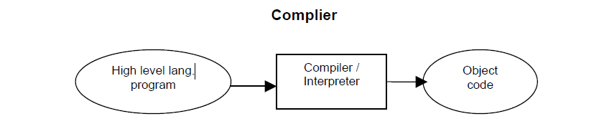 Differences between Compiler & Interpreter
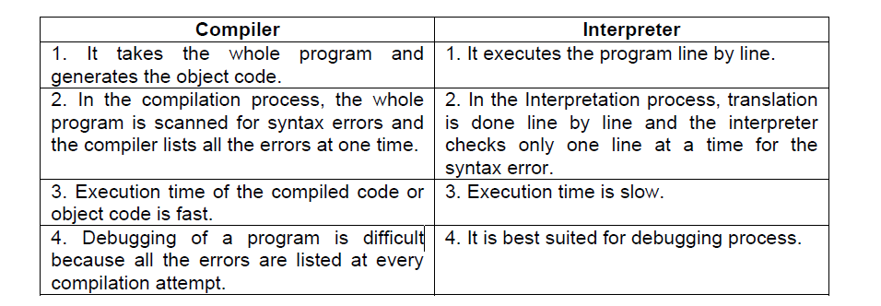

Parts of a Computer
To learn more about the components of a computer, let us examine the various parts that are visible from outside. Basically, a computer consists of a CPU, a monitor, a mouse and a keyboard. Some Computers may also contain additional accessories like speakers, a microphone, a headphone etc. The additional accessories simply facilitate us to use the computer for doing something extra. A discussion on the essential and optional components of the computer will be taken up later on in this chapter. For the moment, let us discuss the components of a simple computer.

- Central Processing Unit (CPU): The Central Processing Unit (CPU) of computer is usually located in a tower-shaped cabinet. The CPU consists of different smaller components like the motherboard, hard disk, RAM, floppy disk drive, sound card etc. These components are discussed in the next section.

- Monitor: Monitor is television-like equipment which displays the output of a computer. Monitors can be monochrome (black and white), LCD (liquid crystal display), VGA or SVGA. Further, monitors can be analogue or digital.

The monitor of a PC works like a television screen. It displays text characters and graphics in colors or in shades of grey. The monitor is sometimes also known as screen display or a CRT (cathode Ray Tube). An image is made up of tiny dots called pixels. Anything typed on the keyboard is displayed on the monitor. When a program is executed, the information is displayed on the monitor. However, the results on the screen are shown only temporarily and are not permanent unless they are saved in the hard disk.

Various types of monitors are, the monochrome monitor and the colour monitor differ in terms of their resolution (i.e. the sharpness of the image on the screen). Higher the resolution, higher the cost. Coloure monitors have a higher resolution High resolution monitors are used for specialized jobs, like creating graphics and images.

- Mouse: Mouse is a small component that fits inside out palm. Mouse is a rectangular-shaped device, with a rubber ball (tracking ball) embedded at its lower side and buttons on the top. This hand-held device allows you to control computer without having to type instructions from the keyboard. It serves to move around your computer screens as wells as to active commands. Working on a computer through a mouse is easy to faster as compared to the keyboard.
The mouse is generally available in two types:
- Two Button mouse; and
- Three Button mouse.

- Keyboard: Keyboard is a typewriter like device which contains key to feed information into the computer. Keyboard is a typewriter-like device which contains key to feed information into the computer.
- The standard keyboard with 83 – 84 keys; and
- The enhanced keyboard with 104 keys or more
Components of a PC
Basic Components | Optional
- Processor  - Hard disk  - RAM  - Display / Video card  - Keyboard  - Drives : Hard Disk, Floppy Disk and CD-ROM  - Mouse  - Monitor | - Printer  - Scanner  - Modem  - DVD drive  - Speakers  - Zip Drive

- The System Unit
The Keyboard, monitor, mouse, printer, etc. are all linked to the System Unit through cables which are plugged into the back of the System Unit. The hard disk, the floppy disk drive and the CD-ROM drive are placed inside this unit.

Vital components of the System Unit.
- Hard Disk: The hard disk is a device which stores all programs and data in the computer. The capacity of the hard disk is measured in Giga Bytes (GB). Larger the hard disk capacity, more the amount of software programs and information that can be stored in it.

- Motherboard: The motherboard is a flat platform of fibre glass on which the electronic components in a PC are mounted. The motherboard is also called a Printed Circuit Board (PCB)
- Central Processing Unit (CPU): The Central Processing Unit (CPU) contains the microprocessor chip which undertakes all the thinking for the PC and runs the programs according to the user’s commands and requests.

Following are the various types of CPU chips:
  - Pentium
  - Pentium Pro
  - Pentium III
  - Pentium IV
  - AMD Athlon
  - Intel Celeron
  - AMD Duron
  - Cyrix

- CD-ROM Drive: CD-ROM drive is a device that reads the information stored on CD-ROM disks, CD-ROM is an abbreviated term for ‘Computer Disk – Read Only Memory’. The Speed of a CD-ROM drive is indicated by a number followed by the alphabet ‘X’. The 56X CD-ROM is currently the most popular drive specification. The CD-ROM disk is flat and circular in shape and can store a lot more information as compared to a floppy disk.

- Floppy Disk Drive: Floppy disk drive is a component that enables us to read/store information on floppy disks. The floppy disk drive consists of a slot to accept a floppy disk, a motor to spin the disk, and a recording/reading device that moves across the disk to read or write data. A floppy disk (also called diskette) is used to store information just as hard disk. It is a removable device, its capacity is (1.44 MB). A PC has 3½ “ floppy disk drive.
- RAM Chips: RAM stands for Random Access memory, RAM chips are components that help the computer to hold the program and it data temporarily while the computer is working. RAM chips come in memory sizes of 16 MB, 32 MB, 64 MB, 128 MB and so on.
- RAM Chip Slots: These slots are meant to expand the computer’s random access memory by incorporating additional RAM chips.

- SCSI: SCSI stands for ‘Small Computer System Interface’ (pronounced skuzzy). An SCSI provides an internal connector which in turn allows to connect the computer to an external storage dev ice.

- Power Supply Unit: The components in a PC can work only when they get electric supply. Most components require a 5 Volt supply while the floppy and the hard disk require about 12 Volts. The power supply unit safeguards the PC components by converting high-voltage current to low voltage.
- Disk Drive Control Card: This stand controls the disk drive motors of the PC and transfers data to the control circuitry and directs the read/write heads to access data on the disk. It is permanently inserted in the motherboard.

- Display/Video/Graphic Card: Display card is used to display the data to the user. It is indirectly linked with the computer memory. Nowadays, it is inbuilt in the motherboard. Two types of display cards are available. PCI graphics card and the AGP card.
- Printer Adaptor Card: The display / printer adaptor card is the link between the PC’s memory, the monitor and the printer. It displays the information on the monitor as well as allows it to be printed.

- Expansion Slots: Expansion slots are long and narrow connectors which allow to plug in expansion cards (also called adaptor cards), like the sound card, network card etc.

- ROM Chips: Read Only Memory (ROM) chips have data written on them during manufacturing, that tells the CPU the tasks that it needs to carry out when the CPU switched on.

- Sound Card: This card allows you to play sound and music. The sound card converts the digital information into electrical signals that speakers use. When the speaker is connected to the sound card, the sound can be heard on the speaker.

- The Front Part of a System Unit
The various components seen in the front part of a System Unit and their functions:

a) Power switch: The power on/off switch is used to turn on or off the power to the PC.

b) Reset button: This button helps to restart the computer without disconnecting the power supply.

c) Lights: The front panel of the system unit may display a variety of cloloured indicator lights including power and turbo signals. These lights are used to indicate whether the hard disk, the floppy disk or the CD-ROM is being read or written.

d) Floppy Disk Drive: The System Unit contains a slit in which the floppy disk can be inserted.

e) CD-ROM Drive: CD-ROM drive is used for reading the information stored on CD-ROM disks.

f) Removable Storage Drives: Removable storage drive is an external device that can be connected to the computer are CD writers and rewriters.

- The Backside of a System Unit
The back of the System Unit contains ports of various types. These are the Parallel Port, the Serial Port and the Universal Serial Bus (USB).

Power IN and OUT Sockets: The sockets have cables plugged into them, which carry the power from the electrical outlet to the System Unit, and from the System Unit to the monitor.

Serial Ports: Serial ports connect the PC to a mouse or a modem. Most PCs are fitted with two serial ports.

Video/Monitor Port: A cable from the monitor plugs into the video/monitor port and carries the information to be displayed on the monitor.

Parallel port: The parallel port is usually used for connecting the computer to a printer. Very often, it is referred to as the printer port. Its data transfer speed is about eight times faster than the serial port.

Keyboard Port: The cable from the keyboard plugs into the keyboard port.

USB Port: A USB port is used for connecting any device with a USB connection.

Fan Housing: During operation, the electronic, components in a PC generate a lot of heat, which is liable to overheat the system. To remove excess heart from the system, fan is placed at the back of the unit.

Audio jack: An audio jack is used for connecting devices such as speakers headphones or microphones.

Modem jack: This jack is mainly used in case of internal modems.

SCSI port: The Small Computer System Interface (SCSI) port is used to connect the external hard drive, the DVD drive or the scanner.

Network port: The network port allows you to connect a computer to other computers in a network.
- Additional Devices
- The Printer
After creating a document on the computer, you can send it to the printer for printing its hard-copy which is generally called a printout. The speed of a printer is rated either by pages per minute (ppm) or by characters per second (cps). Characteristics of the commonly used printers.
Printer Name | Speed | Price | Technology
DOT-MATRIX PRINTER | 25 to 450 characters per second or 1 to 18 pages perminute | Least expensive | Works by impact
INKJET PRINTER | 0.5. to 4 pages per minute | Less expensive than colour laser printer | Sprays ink through holes onto a page
LASER PRINTER | 4 TO 24 PAGES PER MINUTE | Expensive | Uses a fine powdered ink called toner

- The Scanner
The scanner is a device that can transfer typed or handwritten texts, graphs, diagrams and photographs to the computer. Scanners can be used for storing photographs and important documents in their original forms. They may also be used to take in enormous text material that otherwise would be very tedious to type manually. Types of scanners that are commonly used:
- The Modem
The Modem is technically called the ‘Modulator Demodulator’. It is an electronic device, which helps transmit programs and data locally or around the world through the telephone line. The main function of a modem is to transform digital signals into analog signals and vice versa.
A modem may be a card mounted inside the PC (an internal modem), or it may be a separate piece of equipment that connects to the serial port of the PC via a cable (an external modem). Telephone lines then connect the modem to the telephone service.

Assignment 1
- What is mean by computer? Classification of computer system and History of computers?
Ans: Define computer
- Classification of Computer Systems :Classification of Computers is based on following 4 criteria:
- 1. According to Purpose
- 2. According to Technology Used
- 3. According to Size and Storage Capacity
- 4. According to Historical Advancement
- 1. According to Purpose
- It is divided into 2 types:
- 1. General Purpose Computers
- 2. Special Purpose Computers
- 2.According to Technology Used
It is divided into 3 types:
- 1. Analog Computers
- 2. Digital Computers
- 3. Hybrid Computers
- According to Size and Storage Capacity
It is divided into 4 types:
- 1. Supercomputer
- 2. Mainframe Computer
- 3. Minicomputer
- 4. Microcomputer
- 4. According to Historical Advancement
It is divided into 6 Generation types:
- 1. Zeroth Generation Computers (1642 – 1946)
- 2. First Generation Computers (1946 – 1954)
- 3. Second Generation Computers (1954 – 1964)
- 4. Third Generation Computers (1964 – 1980)
- 5. Fourth Generation Computers (1980 – till date)
- 6. Fifth Generation Computers (Tomorrow’s Computers)

